**CIS3100**

**KARY HUANG**

**ASSIGNMENT #3**

**04/04/2016**

**INPUT**

//Kary Huang Assignment 3 with EC#1

#include <iostream>

#include <cmath>

#include <fstream>

#include <iomanip>

using namespace std;

int main()

{

ofstream a3out ("a3out.out");

a3out << "Employee ID" << setw(3) << " " << "Previous Salary" << setw(3) << " " << "Current Salary"

<< setw(3) << " " << "Increase" << setw(3) << " " << "Comment" << endl;

int empl_id = 1, prev_salary, current_salary, salary_increase, count = 0;

float total_increase = 0.0, avg_increase;

cout << "Please enter your four digit employee ID: " << endl;

cin >> empl_id;

while (empl_id != 0) //because employee ID cannot be 0

{

while (empl_id >= 10000)

{

cout << "Error. Please re-enter a four digit employee ID: " << endl;

cin >> empl_id;

}

cout << "Please enter last year's salary: " << endl;

cin >> prev_salary;

cout << "Please enter this year's salary: " << endl;

cin >> current_salary;

a3out << empl_id << setw(10) << " " << prev_salary << setw(14) << " " << current_salary << setw(13) << " ";

salary_increase = current_salary - prev_salary;

while (salary_increase < 0)

{

cout << "Error. Please re-enter this year's salary: " << endl;

cin >> current_salary;

salary_increase = current_salary - prev_salary;

}

a3out << salary_increase << setw(7) << " ";

if (salary_increase > 5000)

a3out << "Nice increase" << endl;

else if (salary_increase >= 1000 && salary_increase <= 5000)

a3out << "Fair increase" << endl;

else if (salary_increase < 1000)

a3out << "Small increase" << endl;

count++;

total_increase = total_increase + salary_increase;

cout << "\nPlease enter your four digit employee ID: " << endl;

cin >> empl_id;

}

avg_increase = total_increase / count;

a3out << "\nThe number of employees processed is " << count << "." << endl;

a3out << "The average increase is " << avg_increase << endl;

a3out.close();

return 0;

}

**OUTPUT**

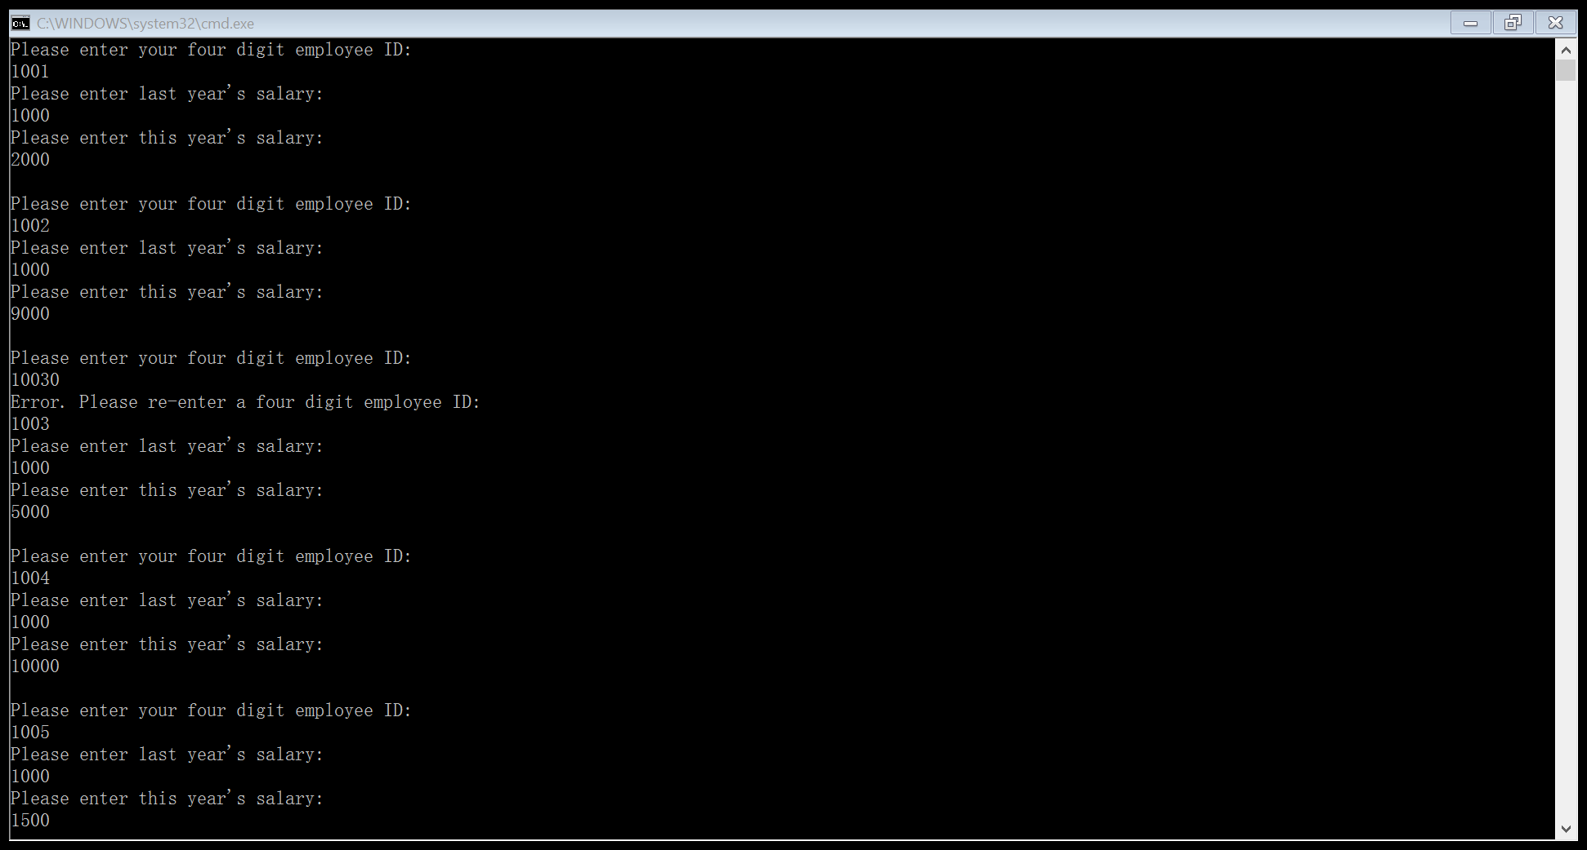 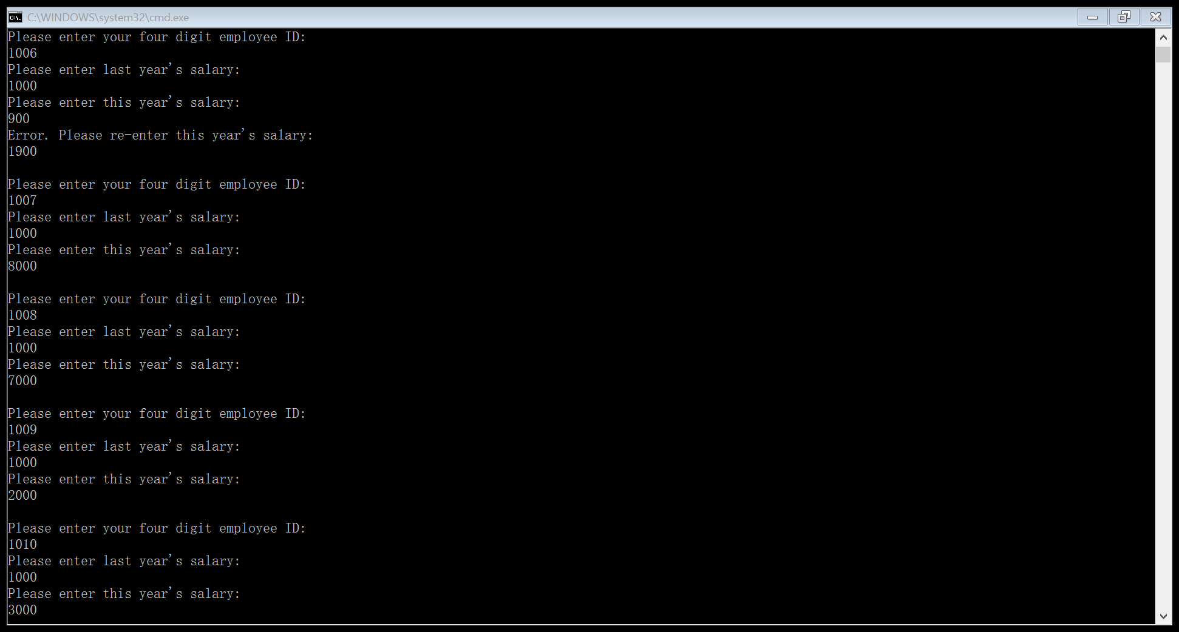

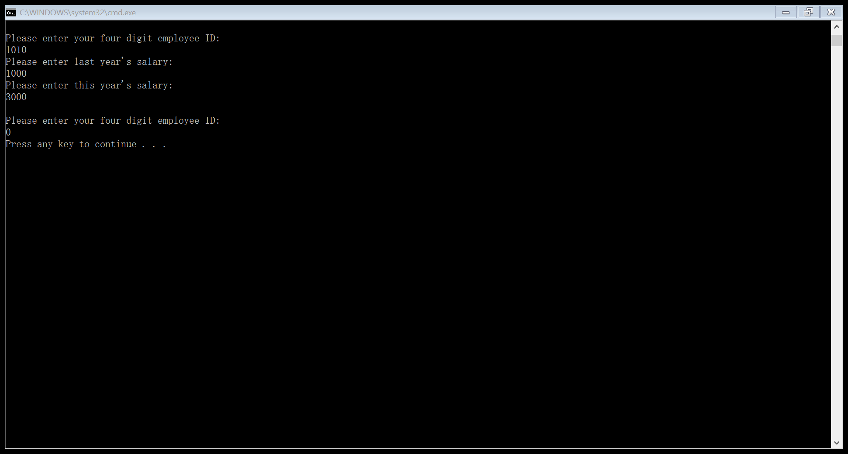

**a3out.out**

